THANK YOU, VALLEY ELEMENTARY
for helping the Rachel’s Challenge/Chain Links Club
collect thousands of can tabs this year!
The tabs were recycled for cash and the money was sent to the Pulaski Middle School to help fellow students impacted by the tornado in their town.
See Pulaski Middle School principal’s note below:
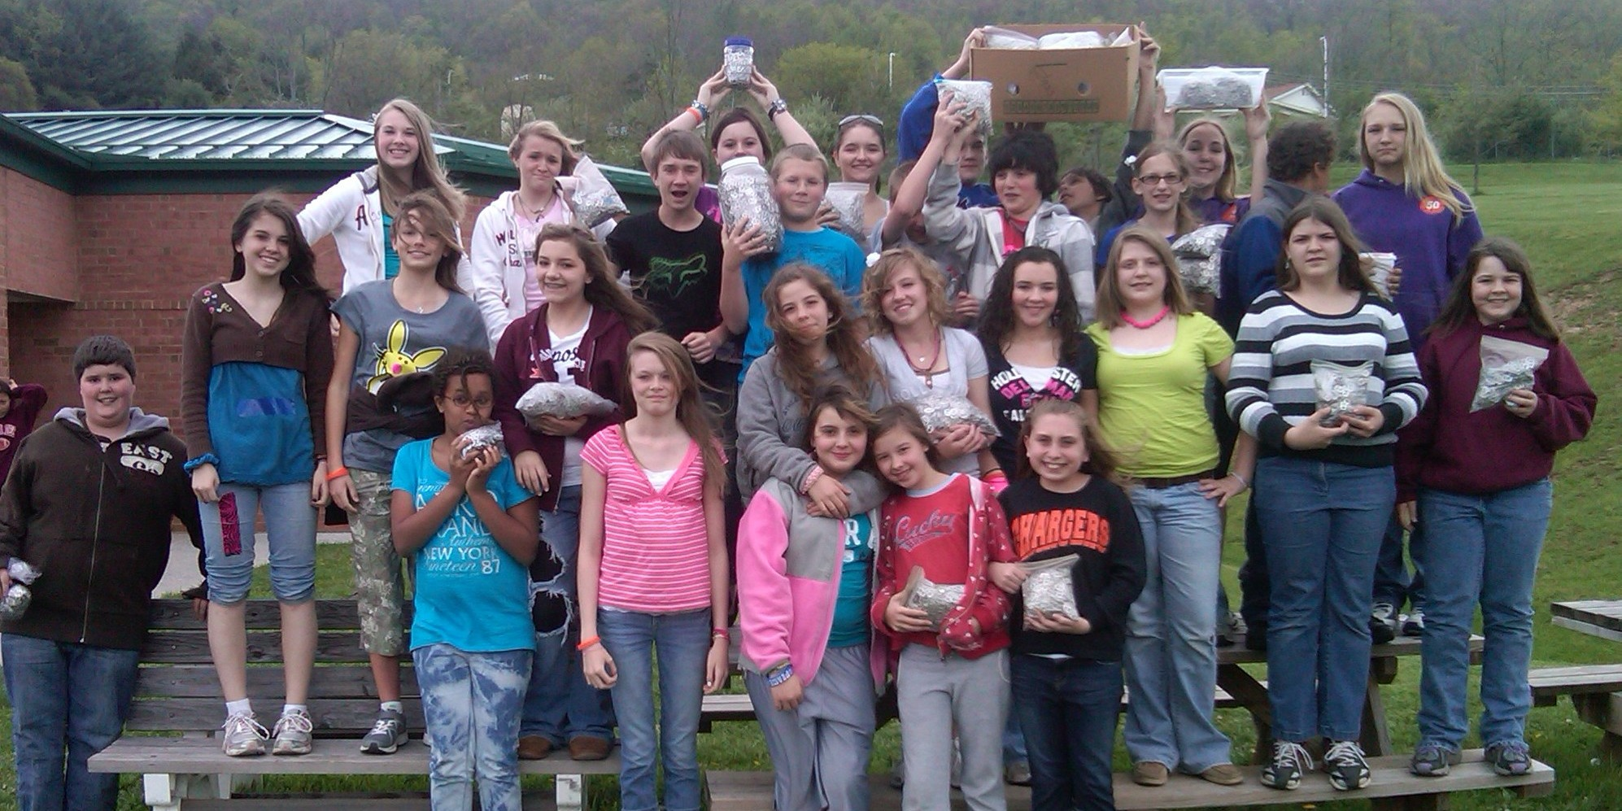
Dear Mrs. Martin, Mrs. Rosenberg, and Rachel's Challenge Club members,

Today, I received your generous donation to our Pulaski Middle School Student Needs Fund. As we discussed, this money will be used to assist our students who were adversely affected by the tornadoes that ravaged our community the evening of April 8th. I am especially touched by the fact that the majority of this donation was the result of the students' recycling efforts. I appreciated learning how Rachel's Challenge came about in memory of the generous and kind Rachel, the first person shot at Columbine. You also explained that the club is sometimes referred to as the Chain Links Club to emphasize the philosophy of how each student can start a chain reaction of kindness...What a wonderful tribute to Rachel!

On behalf of the students at Pulaski Middle School, I thank each and every one of you and commend you for your good works. Our world is a better place because of you. You are a blessing and an inspiration!

Sincerely,

Michael Perry, Ph.D.

